Basic health check, starting and stopping of Goldengate in cluster and single node

We can check the running node of golden gate in cluster by

Crsctl stat res –t

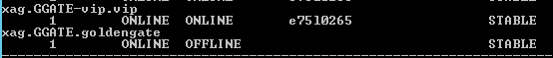

To start and stop the goldengate in cluster environment.

D:\app\xag\bin>agctl start goldengate GGATE

D:\app\xag\bin>agctl stop goldengate GGATE

To start and stop the goldengate in single node environment

In single node we can start and stop the goldengate by starting and stopping the Manager.

GGSCI > start manager

GGSCI >stop manager

To check the running status of the Goldengate

GGSCI> info all

We need to check the running status and Lag as per below screenshot

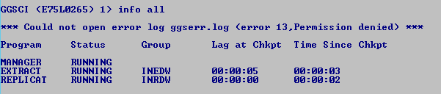

Error log(alert log)

Ggserr.log

Note: In our environment, Goldengate running in Prod and SITDW databases, below find the home path of goldengate for these environments, where we can run GGSCI interface to check the status and where we can find all the logs .

Prod:

G:\Oracle\Goldengate

SITDW

D:\Oracle\GoldengateNew

